PRODUCT

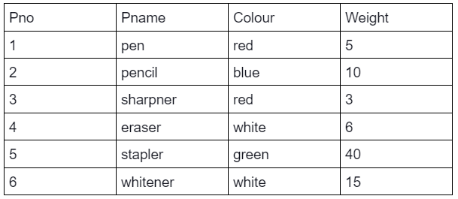

SUPPLIER

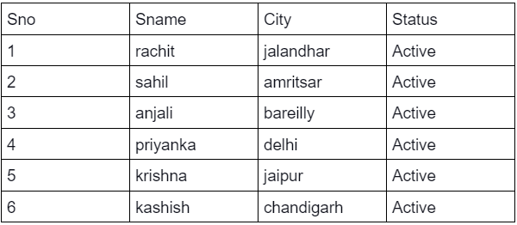

SP

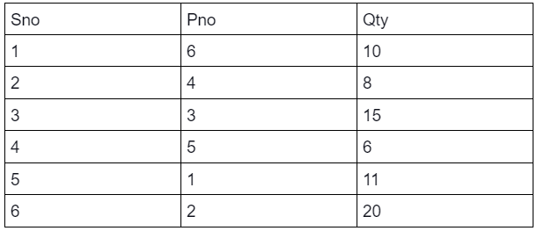

SAILOR

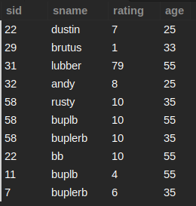

BOATS

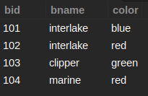

RESERVES

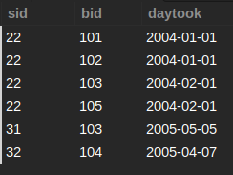

EMPLOYEE

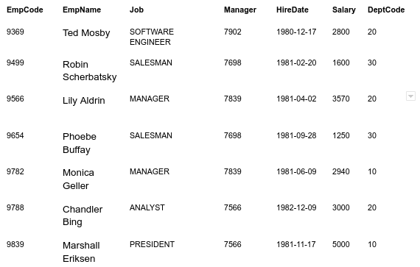

Q91: Write a SQL query to find out the quantity supplied by anjali and rachit.

SELECT QTY FROM SP WHERE SNO IN (

SELECT SNO FROM SUPPLIER WHERE SNAME IN ('rachit', 'anjali')

);

+------+

| QTY |

+------+

| 10 |

| 15 |

+------+

Q92: Write a SQL query to display the supplier name and city of the supplier who supplies parts with Pno 1 and 5.

SELECT SNAME, CITY FROM SUPPLIER WHERE SNO IN(

SELECT SNO FROM SP WHERE PNO IN (1, 5)

);

+----------+--------+

| SNAME | CITY |

+----------+--------+

| priyanka | delhi |

| krishna | jaipur |

+----------+--------+

Q93: Write a SQL Query to get the colour of parts supplied by Supplier with Sno 1,3,6

SELECT COLOUR FROM PRODUCT WHERE PNO IN (

SELECT PNO FROM SP WHERE SNO IN (1,3,6)

);

+--------+

| COLOUR |

+--------+

| blue |

| red |

| white |

+--------+

Q94: Write a SQL query to get the colour of parts supplied by all the employees except rachit and kashish.

SELECT COLOUR FROM PRODUCT WHERE PNO IN (

SELECT PNO FROM SP WHERE SNO IN (

SELECT SNO FROM SUPPLIER WHERE SNAME NOT IN ('rachit', 'kashish')

)

);

+--------+

| COLOUR |

+--------+

| red |

| red |

| white |

| green |

+--------+

Q95: Print the name and age of all oldest sailors.

SELECT SNAME, AGE FROM SAILORS WHERE AGE IN (

SELECT MAX(AGE) FROM SAILORS

);

+--------+------+

| SNAME | AGE |

+--------+------+

| lubber | 55 |

| buplb | 55 |

| bb | 55 |

| buplb | 55 |

+--------+------+

Q96: Write a SQL Query to get the supplier name who supply pencils with quantity greater than 10.

SELECT SNAME FROM SUPPLIER WHERE SNO IN(

SELECT SNO FROM SP WHERE QTY > 10 AND PNO IN (

SELECT PNO FROM PRODUCT WHERE PNAME='PENCIL'

)

);

+---------+

| SNAME |

+---------+

| kashish |

+---------+

Q97: List down all the Employees whose salary is greater than that of Monica Geller.

SELECT EMPNAME FROM EMPLOYEE WHERE SALARY > (

SELECT SALARY FROM EMPLOYEE WHERE EMPNAME = 'Monica Geller'

);

+------------------+

| EMPNAME |

+------------------+

| Lily Aldrin |

| Chandler Bing |

| Marshall Eriksen |

+------------------+

Q98: List down all the employees whose job is the same as Phoebe Buffay.

SELECT EMPNAME, SALARY, DEPTCODE, JOB FROM EMPLOYEE WHERE JOB IN (

SELECT JOB FROM EMPLOYEE WHERE EMPNAME IN ('Phoebe Buffay')

);

+-------------------+--------+----------+----------+

| EMPNAME | SALARY | DEPTCODE | JOB |

+-------------------+--------+----------+----------+

| Robin Scherbatsky | 1600 | 30 | SALESMAN |

| Phoebe Buffay | 1250 | 30 | SALESMAN |

+-------------------+--------+----------+----------+

Q99: Print out all the employees with their respective Departments if there is at least one employee whose salary is more than 4000.

SELECT EMPNAME, DEPTCODE FROM EMPLOYEE WHERE EXISTS (

SELECT EMPNAME FROM EMPLOYEE WHERE SALARY > 4000

);

+-------------------+----------+

| EMPNAME | DEPTCODE |

+-------------------+----------+

| Ted Mosby | 20 |

| Robin Scherbatsky | 30 |

| Lily Aldrin | 20 |

| Phoebe Buffay | 30 |

| Monica Geller | 10 |

| Chandler Bing | 20 |

| Marshall Eriksen | 10 |

+-------------------+----------+

Q100: Find the name of boats and their respective colors of the sailors with minimum age.

SELECT BNAME, COLOR FROM BOATS WHERE BID IN (

SELECT BID FROM RESERVES WHERE SID IN (

SELECT SID FROM SAILORS WHERE AGE IN (

SELECT MIN(AGE) FROM SAILORS

)

)

);

+-----------+-------+

| BNAME | COLOR |

+-----------+-------+

| interlake | blue |

| interlake | red |

| clipper | green |

| marine | red |

+-----------+-------+

Q101: Find the IDs of sailors and their daytook for sailors with highest rating.

SELECT SID, DAYTOOK FROM RESERVES WHERE SID IN(

SELECT SID FROM SAILORS WHERE RATING IN(

SELECT MAX(RATING) FROM SAILORS

)

);

+------+------------+

| SID | DAYTOOK |

+------+------------+

| 31 | 2005-05-05 |

+------+------------+

Q102: Write a SQL query for the red-colored products whose original weight is less than 10 units; displaying information in the output table as: product name, colour and 20 times the original weight as 'w'.

SELECT PNAME, COLOUR, WEIGHT*20 AS W FROM (

SELECT * FROM PRODUCT WHERE WEIGHT < 10 AND COLOUR = 'red'

) AS T1;

+----------+--------+------+

| Pname | Colour | W |

+----------+--------+------+

| pen | red | 100 |

| sharpner | red | 60 |

+----------+--------+------+

Q103: List down the employee details with their annual salary, given that the annual salary of the employees being listed should be greater than 30000

SELECT EMPCODE, EMPNAME, SALARY, SALARY*12 AS A_SAL FROM EMPLOYEE WHERE SALARY*12 IN (

SELECT SALARY*12 AS A_SAL FROM EMPLOYEE WHERE SALARY*12 > 30000

);

+---------+------------------+--------+-------+

| EMPCODE | EMPNAME | SALARY | A_SAL |

+---------+------------------+--------+-------+

| 9369 | Ted Mosby | 2800 | 33600 |

| 9566 | Lily Aldrin | 3570 | 42840 |

| 9782 | Monica Geller | 2940 | 35280 |

| 9788 | Chandler Bing | 3000 | 36000 |

| 9839 | Marshall Eriksen | 5000 | 60000 |

+---------+------------------+--------+-------+

Q104: Print the employee details for all employees who earn more than the average salary and having an “e” in their name.

SELECT EMPCODE, EMPNAME, SALARY FROM EMPLOYEE WHERE EMPNAME LIKE '%e%' AND SALARY > (

SELECT AVG(SALARY) FROM EMPLOYEE

);

+---------+------------------+--------+

| EMPCODE | EMPNAME | SALARY |

+---------+------------------+--------+

| 9782 | Monica Geller | 2940 |

| 9788 | Chandler Bing | 3000 |

| 9839 | Marshall Eriksen | 5000 |

+---------+------------------+--------+

Q105: Find the ids and names of sailors who have reserved at least two different boats.

SELECT SID, SNAME FROM SAILORS WHERE SID IN (

SELECT SID FROM (

SELECT SID, COUNT(SID) AS CNT FROM RESERVES GROUP BY SID

) AS R WHERE R.CNT > 2

);

+------+--------+

| SID | SNAME |

+------+--------+

| 22 | dustin |

| 22 | bb |

+------+--------+

Q106: Fetch out the color, sailor id and boat id of the boats reserved by the Sailor having 2nd highest rating. Order the result based on the bid in descending order.

SELECT B.COLOR, S.SID, B.BID FROM SAILORS S, BOATS B, RESERVES R

WHERE S.SID = R.SID AND B.BID = R.BID AND S.RATING IN (

SELECT MAX(RATING) FROM (

SELECT RATING FROM SAILORS WHERE RATING NOT IN (SELECT MAX(RATING) FROM SAILORS)

) AS T1

);

+-------+------+------+

| COLOR | SID | BID |

+-------+------+------+

| green | 22 | 103 |

| red | 22 | 102 |

| blue | 22 | 101 |

+-------+------+------+

Q107: Display all the sailor id, boat id and sailor name which are reserved by Sailors who have ratings more than the average rating in the reserves table.

SELECT S.SID, R.BID, S.SNAME FROM SAILORS S, RESERVES R

WHERE S.SID = R.SID AND S.RATING > (

SELECT AVG(RATING) FROM SAILORS

);

+------+------+--------+

| SID | BID | SNAME |

+------+------+--------+

| 31 | 103 | lubber |

+------+------+--------+

Q108: Display all the sailor id, boat id, sailor name and boat color which are reserved by Sailors who have ratings less than the average rating in the reserves table.

SELECT R.SID, R.BID, S.SNAME, B.COLOR FROM SAILORS S, RESERVES R, BOATS B

WHERE S.SID = R.SID AND B.BID = R.BID AND S.RATING < (

SELECT AVG(RATING) FROM SAILORS INNER JOIN RESERVES WHERE S.SID = R.SID

);

SELECT r.sid , r.bid, s.sname, b.color FROM reserves AS r, boats AS b, sailors AS s

WHERE s.sid = r.sid AND r.bid = b.bid AND s.rating < (

SELECT AVG(rating) FROM reserves INNER JOIN sailors WHERE s.sid = r.sid

);

+------+------+--------+-------+

| sid | bid | sname | color |

+------+------+--------+-------+

| 22 | 103 | dustin | green |

| 22 | 102 | dustin | red |

| 22 | 101 | dustin | blue |

| 32 | 104 | andy | red |

| 22 | 103 | bb | green |

| 22 | 102 | bb | red |

| 22 | 101 | bb | blue |

+------+------+--------+-------+